Sustainability:
Making Dents for Decades



Ten Year Sustainability Plan Year Two
Lambda Beta Chapter
Beta Alpha Psi
Updated Spring 2010

Progress as of February 18, 2010

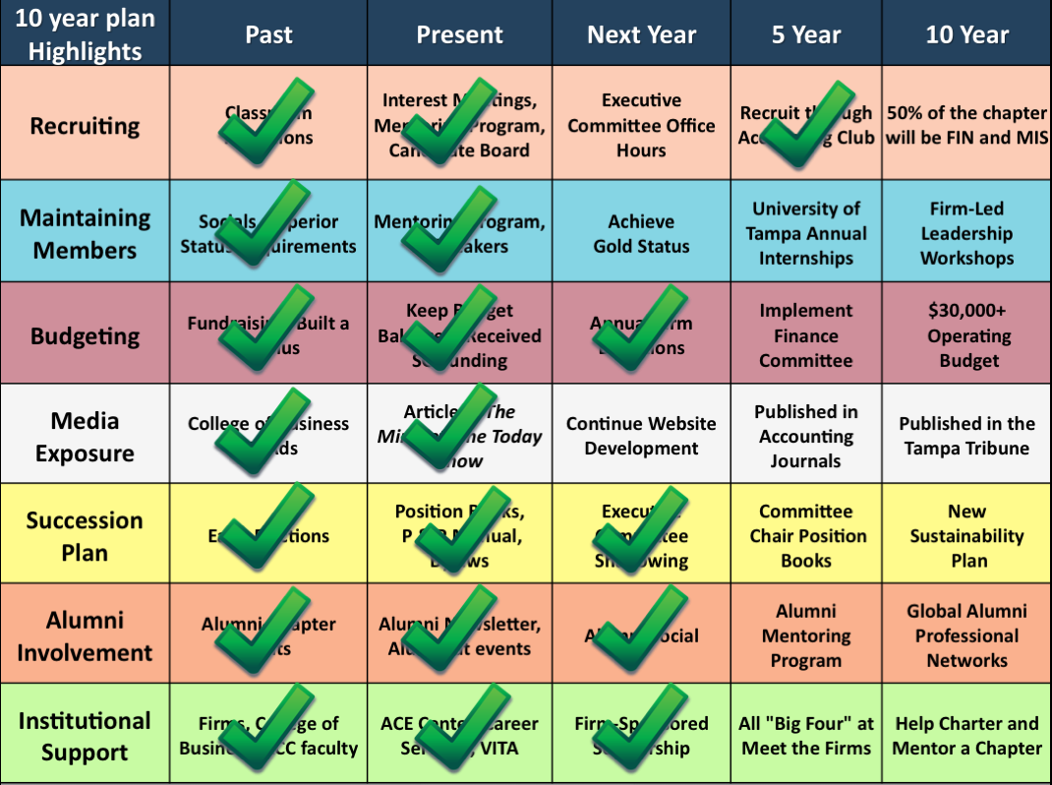

Executive Summary on the Past year

Beta Alpha Psi chapters’ activities, programs, and events carry a greater weight and value than just their immediate benefit in any particular year. The leadership of each chapter should be focused not only on the present, but they should be looking towards the future to ensure the chapter remains an organization, which identifies apt students, develops those students, and betters their communities. To do this, chapters’ must focus on all aspects of their organization, such as recruiting, maintaining members, succession plan, institutional support, alumni involvement, budgeting, and media exposure.

In the past year, the Lambda Beta Chapter has seen tremendous success. All of the goals we wanted to achieve in the past year have been achieved and over half of our goals this year to day. In addition we have events planned that will ensure the completion of our goals this year. We are planning an alumni social, have made a video about our Chapter (in preparation for the Gold Status Video), and we have decided to hold Executive Committee Office hours later this semester.
As another year has past, we have discovered how flexible a Ten Year Plan must be. We are discovering its flexibility not because our chapter has been able to accomplish it’s goals, but we have been moving ahead of schedule.

The Success of the Past Year

“Quality is remembered long after the price is forgotten.” – Gucci Family

When accomplishing goals ahead of schedule, we have had to address the topic of quality control. Although we have accomplished are goals, are they complete? We’re they accurately implemented and accomplished? The answer is yes. We have a culture where we want to dominate an area before we move on, similar to a company who wants to capture their target market before they expand.

Another vital component of our chapter is our website. The website serves the chapter’s interest by adding an entirely new facet of media exposure. Through this increased flow of information, potential candidates, members, alumni, and professionals alike will be kept up-to-date and involved in chapter activities.

Our relationship with the Career Services office provides a powerful connection to some of our greatest allies. The office supports us by co-sponsoring a variety of events. These events include “Meet the Firms”, Mock Career Fairs/Interviews, and resume workshops. On March 26th, 2010, our chapter will partner with Career Services, Delta Sigma Pi, the American Marketing Association, and Student Government, to provide all students on our campus an opportunity to learn about practical and financial challenges. Local business leaders and alumni will visit UT to ensure our fellow students can transition easily into the “real world”. This event illustrates how effective a relationship with campus offices and organizations can be at meeting our chapter’s needs and goals. This is our 3rd annual event, Life After UT.

Each component of a chapter’s sustainability will be covered below has been reevaluated due to the progress over the last year. The sections begin by identifying the importance and goals within each category. Then, the document outlines our past performance, current progress, and future objectives. Furthermore, there are ideas of how to effectively measure a chapter’s progress in each area.

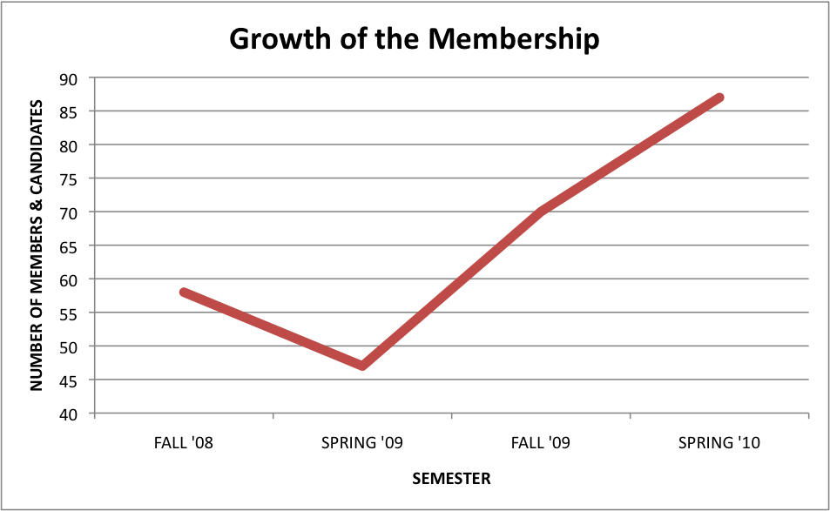

Recruiting

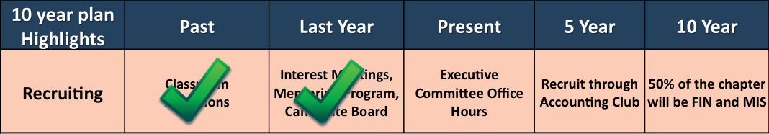
Importance
Since students are only members of Beta Alpha Psi for an average of two years, recruiting new members is a key component to the success and sustainability of our Lambda Beta Chapter. The most significant way to aid the growth of our chapter beyond its current size is to increase recruiting in Accounting and other applicable majors through new and innovative ways.
Ultimate Goal
To dramatically expand the size of our chapter by creating an Accounting, Finance, and Management Information Systems club which will act as funneling organizations into Beta Alpha Psi that will therefore turn 50% of our membership into non-accounting majors. These organizations will provide students a place to start their professional journey and demonstrate the rewards that these majors and our chapter can bring them.
Evaluation of Past Efforts
Our chapter has visited accounting classrooms, at the beginning of each semester, to recruit qualifying students to join Beta Alpha Psi. Also, bringing their attention to BAP when they are in upper-level classes may be too late in their accounting careers. Furthermore, the accounting faculty is a powerful recruiting tool because they can credibly relate to students about the importance of being a part of BAP can be to a future career.
Perhaps our most successful practice in the past was to have the candidate classes elect an Executive Committee from the group to lead and represent them during the candidacy process. This is a great to provide leadership opportunities to the candidates and incentive them to join Beta Alpha Psi.
Current Programs
We hold interest meetings every semester to inform students about Beta Alpha Psi and the benefits of the chapter. This serves as a time for our chapter to “sell” BAP to students and convince them our organization is worth their time and money. One particularly effective practice has been to have alumni come and speak at these meetings about their experiences and how BAP served them during their collegiate experience.
Also, the mentoring program has become the centerpiece of our Lambda Beta Chapter by bridging the gap between candidacy and membership. It also keeps current members involved.
This year, we launched the accounting club, completing one of our ultimate goals. It has already become a major success. They have hosted their own socials, attended select chapter events, and joined our intramural sports teams. In fact the president of the organization was recently elected University of Tampa’s student leader of the month.
We now provide a Beta Alpha Psi Scholarship each semester to the highest achieving candidate in the candidate class. The scholarship is $250 donated by a local firm that continually supports our chapter.
Future Program
In the future, our chapter will implement a finance and information systems club in order to achieve our goal of expansion by funneling students of related majors into Beta Alpha Psi. We have plans set for a leadership camping retreat this coming March which we will continue annually.
Benchmark Measures
- Candidate conversion rate
- Invitation conversion rate
- Percentage of chapter that is non-accounting majors

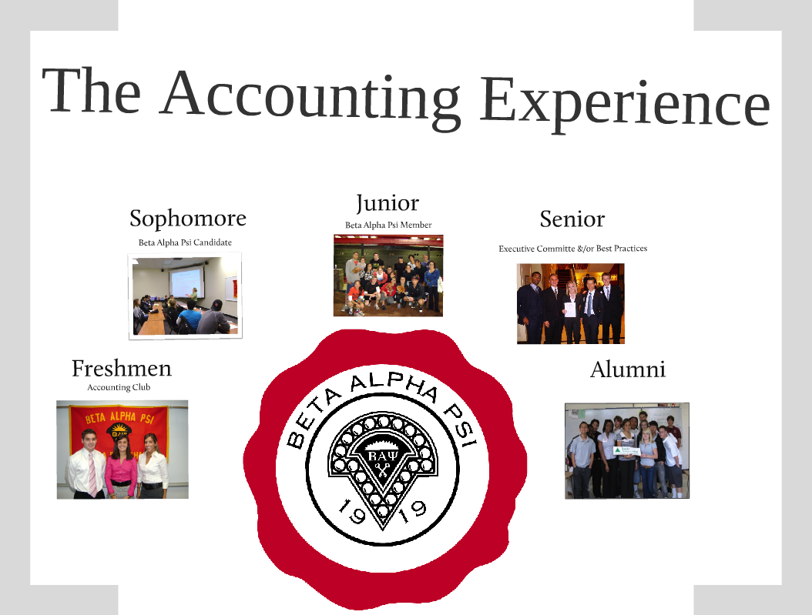

Maintaining Members

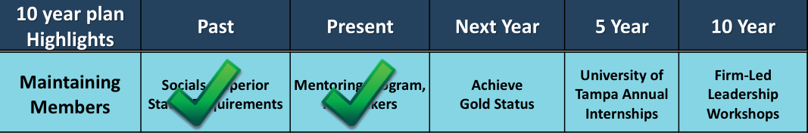

Importance
Maintaining members is crucial to a chapter’s success in order to stay aligned with Beta Alpha Psi’s mission. We need active people to run our programs, events, and participate in philanthropies. Furthermore, we need members to help recruit and effectuate the other goals of the chapter, such as raising funds and developing personally and professionally.
Ultimate Goal
We hope that, in the future, our chapter achieves Gold Status for chapter involvement.
Evaluation of Past Efforts
Our chapter is continually trying to provide value to its members to facilitate long-term involvement. In the past, we have held socials to create a more relaxed environment in BAP and foster participation. For college students, a key factor in motivation is, “What are my friends doing?” So, we hope that members can develop friendships through our organization.
For the last two years, our chapter has required 32 hours of service and professional hours from our members to achieve superior status. This high standard of involvement requires that our members stay active and continue to participate in a variety of programs. We have been able to achieve superior status each year; however, as students age, their level of involvement seems to decline.
Since the fall semester of 2007, icebreakers have been implemented as a ways for to learn about each member of the chapter and create a fun environment. This allows for our candidates and member to feel more relaxed, comfortable and knowledgeable about the people they spend an immense amount of time with.
Current Programs
The mentoring program serves as a way to keep, not only candidates, but also our members involved as well. The members spend time with their mentees and keep them informed of events and activities.
In the past year, our chapter began participating in intramural sports. This has allowed everyone to connect and work as team, while at the same time increasing members and candidates participation within the organization.
The Lambda Beta chapter also provides its members with countless networking opportunities that they would not otherwise have. Providing streams of professional events has been one of the best ways to keep our members active. With the implementation of intramural sports our chapter has even begun to challenge local professionals to games, thus increasing our member’s exposure to networking activities.
A unique recognition program has been devised in order so our appreciation for those members who put in extra work and dedication within the chapter. Recipients of “snuggies” feel accomplished and satisfied with the extra steps taken to make them feel that much more needed and welcomed in our Lambda Beta Chapter. It is because of the extra steps we take, like that of a snuggie reward that allows us to maintain our members.
Future Programs
In the future, our chapter wants to have a guaranteed internship through our chapter and university. The internship would be granted to a new member/candidate each year. We hope to form a partnership with our school’s accounting department, so it can select a member each year to gain practical experience in accounting. We hope that this, and other programs like it, will motivate members to stay active and involved with our chapter, even as they advance in their college years.
Benchmark Measures
- Percentage of active members
- Number of hours earned by members
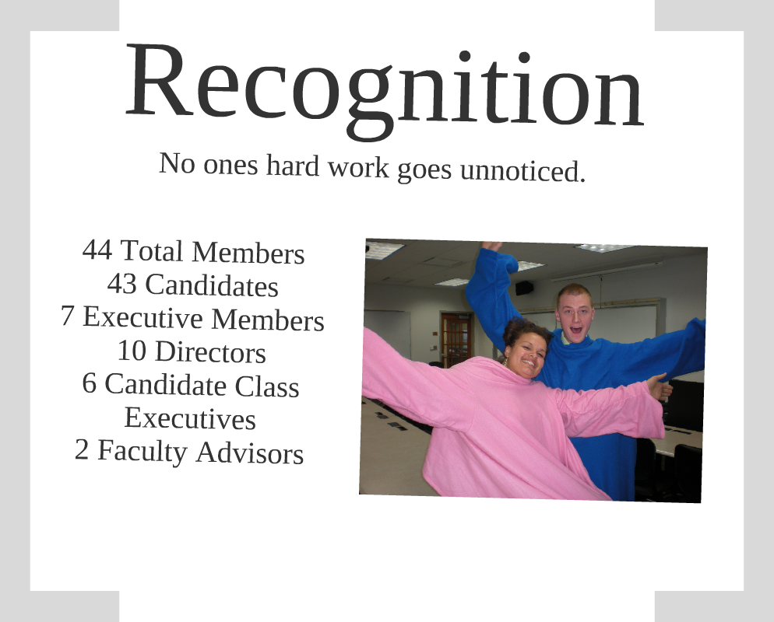

Succession Plan
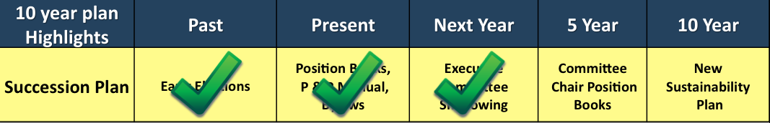
Importance
An effective succession plan is important to prevent future officers from making the same mistakes as their predecessors. Instead, the new executive committee should be able to build on the successes of the previous executive committees. Thus, quality leadership can be achieved to ensure the chapter’s ongoing stability and development.
Ultimate Goal
To create a program/system facilitating smooth transitions between the leaders of our chapter.
Evaluation of Past Efforts
Our chapter tried to use elections early in the semester, preceding the transition, to identify those who would be taking over for the current officers. In theory, this would be effective. However, because of internships and other circumstances, there is too much uncertainty in the lives of accounting students. Officers, who were elected, ended up not taking the position they ran for, due to certain circumstances.
Our chapter has created “position books” to act as training manuals for future officers. These are very effective ways to supplement the exit interviews, where new officers are trained by their predecessors. These exit interviews are insufficient alone, but when paired with the position books, these sessions provide new officers with the necessary information to hit the ground running when they take office.
Current Programs
One way we are trying to identify potential leaders early is by having candidate classes elect their own officers to assist the chapter’s executive committee. These candidate officers also create a mechanism for the candidate classes to organize their efforts to better benefit the chapter.
Furthermore, we have created ten new director positions, which shall act as preliminary training for future executive officers. The positions will cut the amount of time needed for the training of newly elected executive board members to virtually nothing.
In addition, current executive committee members have been instructed to select candidates who have the potential to become leaders as their mentees. This has been quite effective in nurturing the capabilities of our young talent. Current officers are also reminded of the importance of keeping their position books updated, so the tools we provide our new officers with are as effective and helpful as possible.
Future Programs
In the future, our chapter looks to create shadowing programs for each individual executive position, to ensure a smooth and effective transition of officers. This will enable our possible future executive committees to acquire the skills and knowledge needed to be innovative and successful, prior to taking office.
Benchmark Measures
- Officer turnover rate
- Percentage of other chapter goals being met
- “Balanced Scorecard” approach in which officers are surveyed on the quality of their preparation, effectiveness, and experience as officers



Institutional Support

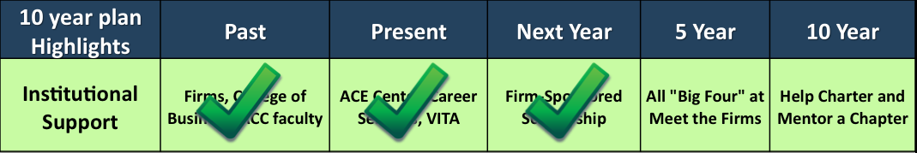

Importance
Our chapter needs partnerships within our academic, business, and social community to accomplish grand goals. Our chapter also needs to be prepared to give back to those communities.
Ultimate Goal
Our chapter wants to become institutional support for our campus, community, and other Beta Alpha Psi chapters. We want to create exciting, permanent programs to better our members, school, and community.
Evaluation of Past Efforts
Our contacts have grown substantially in the seven years we have been in existence thanks to our accounting faculty who have helped us connect with professional organizations and business entities.
Professional organizations provided us with the opportunity to learn how to become business leaders. The local IMA chapter sponsored three students to attend their leadership conference. Local organizations representatives visited our chapter to inform members of the paths that accounting can lead to.
Current Projects
This year, we were fortunate to receive a lot of support from several organizations. A local firm has set up an annual donation with us, and that money is used to sponsor on candidate to join our chapter each semester. Also, the IMA continues to support us and contributed money to the chapter to send candidates and members to their leadership conference.
Our university community provides great institutional support. Career Services sponsors many events with us, such as Meet the Firms/Companies, Mock Career Fairs, Resume Workshops, Mock interviews, and “Life After UT.” Life After UT is an annual event our chapter co-sponsors to educate our members as well as the entire student body about the challenges that students can face after graduation. The John Sykes College of Business helps our chapter advertise events. Furthermore, they pay for our faculty advisors to attend conferences with our members. Student Government has also been a huge help by providing funds for us to attend conferences.

The school’s tutoring center, Academic Center for Excellence (ACE), has given our members jobs and opportunities for service. ACE has hired several of our members to tutor accounting. Many of those tutors volunteer some of their hours to give back to the student body. We continue to raise money along with neighboring Beta Alpha Psi chapters for Relay for Life and our current plan is to raise $2500 for the organization.
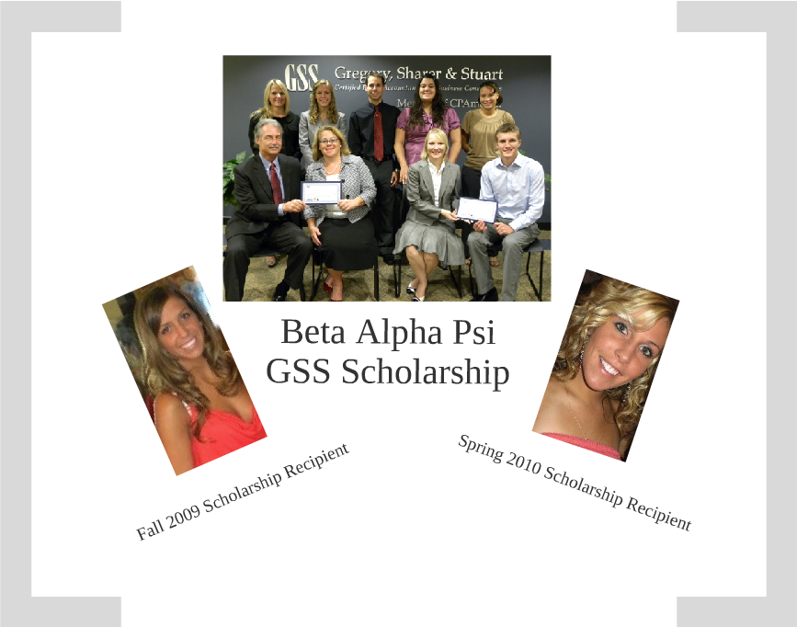

Alumni Involvement
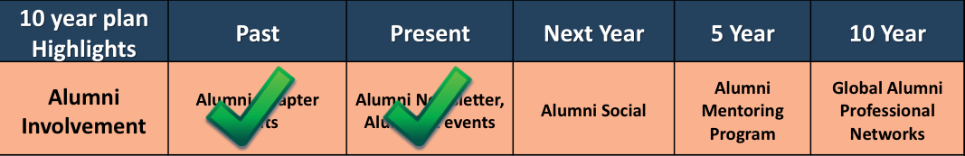
Importance
Keeping our alumni involved is important to the sustainability of our chapter because they can act as mentors for our current members. They can also provide monetary donations to the chapter. Our alumni also create a vital link between our chapter and the business world we hope to become a part of.
Ultimate Goal
To have alumni involved at our initiations, interest meetings, and professional events.
Evaluation of Past Efforts
Our chapter has involved alumni by having them come to speak at our interest meetings. It is a great way to portray the benefits of the Lambda Beta chapter through a living testimonial of their experiences. Our alumni have also come to a number of General Assembly meetings bringing their firm or company with them. In addition last year, Chedu Moyo led our chapter in joining Junior Achievement. We give back to the community by teaching 8th grade students about financial topics.

Current Programs
This year we are in the process of developing a newsletter that we can send to our alumni and keep them informed and involved. We also plan on having alumni at an alumni social during one of our meetings this semester and at initiation.
Perhaps the largest improvement we have made with alumni this year is our website. They can see how involved we are and it really shows how far our chapter has come. In addition each of them can log in and see our current members and their progress!
Future Programs
We hope to create an alumni-mentoring program where our alumni are mentors for our members who are mentors for our candidates. In addition to our future involvement of the alumni, we hope to show them how strong our chapter is and how it can only be made stronger with the help of their donations.

Benchmark Measures
- Size of alumni contacts list
- Percentage of alumni who return within 1 year of graduation
- Percentage of alumni who return after 1 year beyond graduation

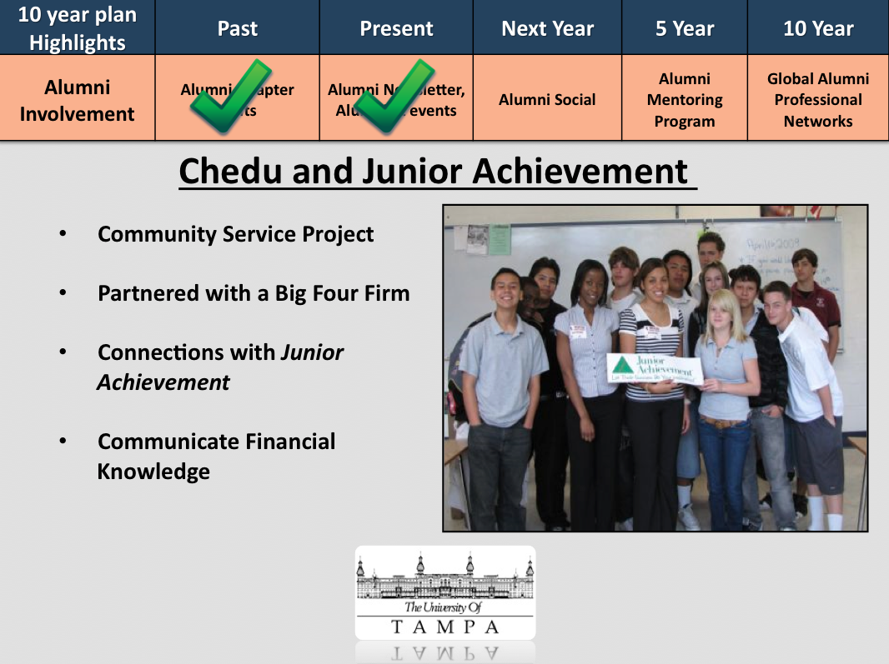

Budgeting

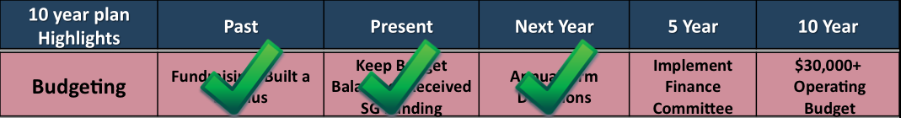
Importance
The chapter needs to be financially stable in order to host events for the members, philanthropy, and to attend conferences. Predicting the amount of cash flow the chapter will have will serve as guide for the executive board to determine where and how to spend the chapter’s money.
Ultimate Goal
Our chapter seeks to maintain our surplus, while developing capital assets and increasing the operating budget along with safe guarding all organizational assets.
Evaluation of Past Efforts
While our past budgeting process lacked organization and chapter involvement, frugal spending and positive fundraising has created a surplus of almost $20,000. In the past budgets where created however never used to analyze the chapter’s expenditures.
Current Budget and Disbursements Process
We post the budget, so the membership can view how where their dues and efforts in fundraising will go. We develop the budget based on historical expenditures and revenues. Our faculty advisor helps keep our grand plans grounded, so our chapter does not waste money. We transferred our surplus into a savings account in order to earn interest monthly. A system of financial controls was established in order to ensure executive board members stayed within their budget.
Future Programs
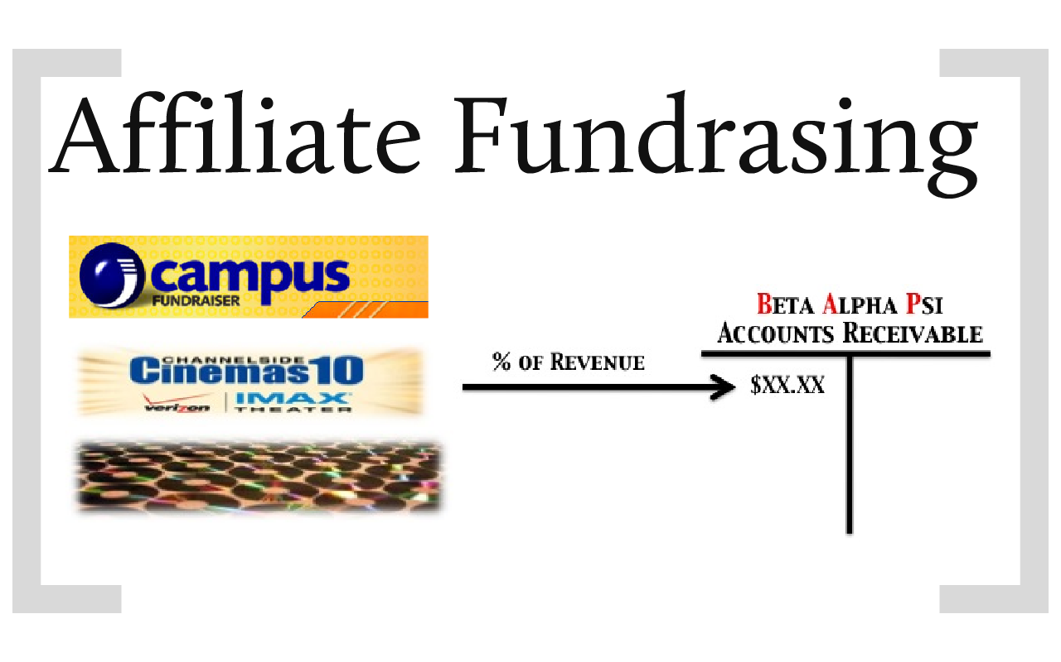
In the future, we hope to create a budgeting committee to oversee the chapter’s finances and help the executive committee make decisions. More immediately, our chapter will have successful self-sustainable and annual fundraisers that will foster membership interaction and growth.
Benchmark Measures
- Percentage of growth or decline in surplus
- Growth of capital assets
- Percentage growth of operating budget

Media Exposure


Importance

Media exposure is important to our chapter because it is an opportunity to illustrate our pride in our organization. Through media covering our events, our community is able to see the hard work and dedication our membership put into strengthening our organization. This promotes our futures activities and raises our reputation with potential recruits.

Ultimate Goal

Through media exposure, we hope to spread the Beta Alpha Psi, and our chapter in particular, name across our campus, local community, and financial information sector.

Evaluation of Past Efforts

We have utilized the resources available to us. For example, our chapter advertised through the Career Services office and the College of Business’s monitors that display upcoming events in hallways. We have also used campus-wide e-mails to promote various activities. And last year we launched our first website which has been a great way for firms and our community to connect with us. We keep them updated on our events and programs.

Current Programs

This year will be our first year with a feature article in the annual yearbook, and we also received an article in the Minaret. In addition, we attended our annual organization fair to get our name out with incoming freshmen even though they cannot join for two years.

This year President Barack Obama came to the University of Tampa for a town hall meeting and three of our members sat behind him on stage. The President and Deans of the University of Tampa chose them. It was great to see our members on TV. They were chosen because of their leadership roles on campus.

Future Programs

In the future, hope to gain an article in the Tampa Bay Tribune, St. Pete Times, or perhaps on the Bay News 9 channel for local news.

Benchmark Measures

- Number of attendants at our events
- Number of people interested in joining
- General sense of community understanding what BAP and our chapter are


